Processes and Threads

Processes:
- The parent uses the fork() system call to create a child
- Every process has a unique process identifier (PID)
- Child PID = 0 if succesfully created.

Process Creation:
• System initialization
• Execution of a process creation system
• User request to create a new process
• Initiation of a batch job

Process Termination:
- voluntary = System call e.g exit(1)
- involuntary = Fatal error / OS
1. Normal exit (voluntary)
2. Error exit (voluntary)
3. Fatal error (involuntary)
4. Killed by another process (involuntary)
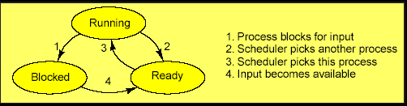
Process States:
- Running = CPU usage
- Ready = waiting for CPU
- Blocked = I/O or thread Synch

Process Hierarchies:
Parent creates a child process, child processes can create its own process
Lowest layer of process-structured OS:
– handles interrupts, scheduling
Pseudo parallelism:
- illusion of programs running simultaniously
Concurrently:
- processes run simultaniously

Resource allocation:
Items Per Process
– Address space
– Global variables
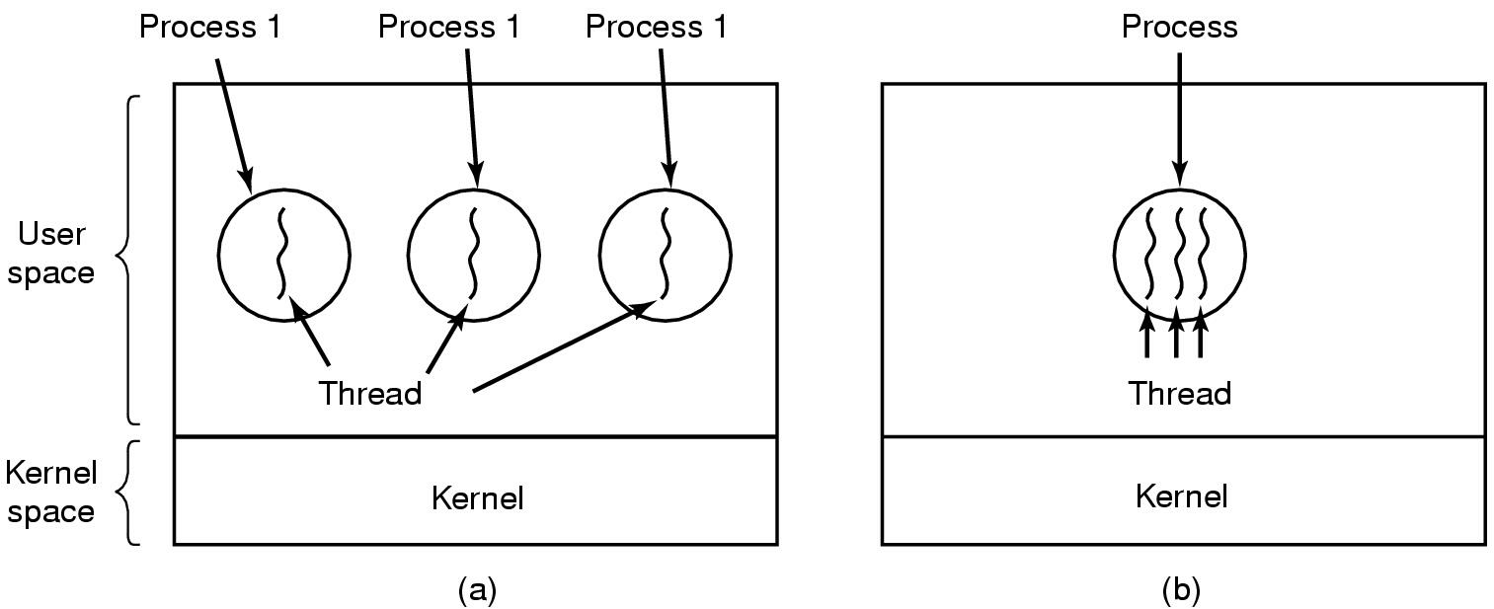
– Open files
– Child processes
– Pending alarms
– Signals and signal handlers
– Accounting information

Items Per Thread
– Program counter
– Registers
– Stack
– State

(a) Three processes with one thread. (b) One process with three threads
Reasons for threads:
- All threads within a process have access to the same data = share the same data
- Easier and faster then processes, threads have little resource.
Problems = difficult to write and debug (concurrency issues)

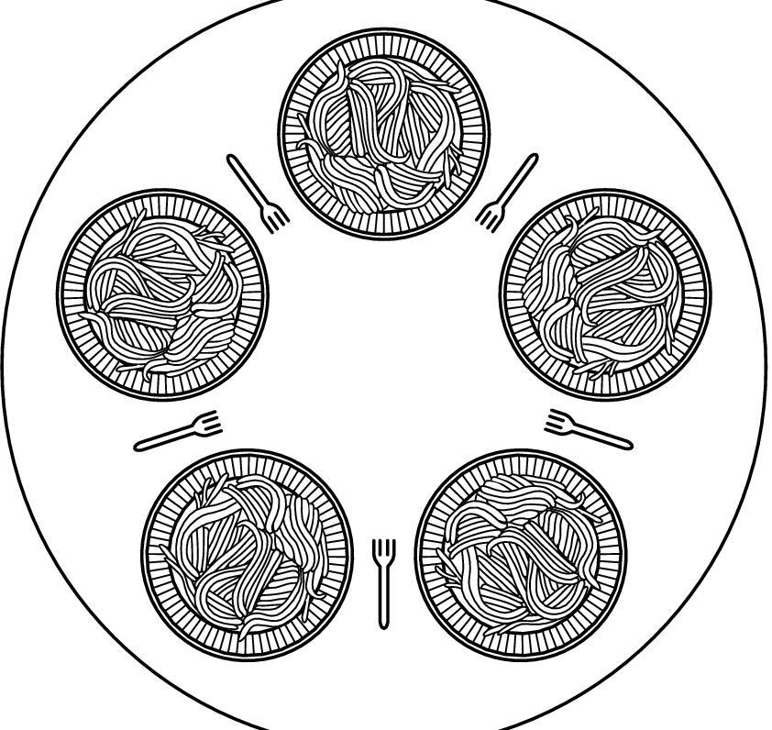
Dining Philosophers Problem:
The Dining Philosopher Problem states that K philosophers seated around a circular table with one chopstick between each pair of philosophers. There is one chopstick between each philosopher. A philosopher may eat if he can pickup the two chopsticks.

- A semaphore per Philosophers and a mutex for regions.
- To avoid Deadlocks, a semaphore is used to determine who can eat.
- To avoid Starvation, a mutex is used to protect the critical region.

Sleeping Barber Problem:
The problem is analogous to that of keeping barbers working when there are
customers, resting when there are none and doing so in an orderly
manner. The barbers and their customers represent threads.
- Three semaphores and a mutex
- one for (waiting) customers, one for (idle) barbers and a mutex.

Customer: When a customer arrives, he attempts to acquire the mutex, and waits until he has succeeded. The customer then checks to see if there is an empty chair for him (either one in the waiting room or a barber chair), and if none of these are empty, leaves. Otherwise the customer takes a seat – thus reducing the number available (a critical section). The customer then signals a barber to awaken through his semaphore, and the mutex is released to allow other customers (or a barber) the ability to acquire it. If a barber is not free, the customer then waits.
Barbers: The barbers sit in a perpetual waiting loop, being awakened by any waiting customers. Once awoken, a barber signals the waiting customers through their semaphore, allowing them to get their hair cut.

Scheduling:
- Process manager handles the removal of running processes.
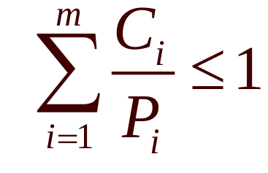
The process scheduling is the activity of the process manager that handles the removal of the running process from the CPU and the selection of another process on the basis of a particular strategy. Process scheduling is an essential part of a Multiprogramming OS.

C = time
P = period

Busy waiting
- Checks to see if condition is true
Starvation
- Denied nessary resourses, Task never finishes
Race condition
- depend on shared software
Deadlock
- A process preventing another from accessing resources

Sample Exam Answer (Processes and Threads)

fork = two processes with one thread each
pthread_create = one process with two threads

After fork(), there are now two processes with one thread each, both continue
executing the same line of code after fork().

Whereas after pthread_create() (which has a parameter which is a pointer to a
function), there is still only one process but now with two threads, where the new
thread begins executing code in a call-back function (i.e. program counter
pointing to first line in this function, not continuing from pthread_create).

Specifically, fork() creates a separate child process of 0, after which the program counter
points to the “if” in both processes. Processes are independent so that if one
process ends the other continues. But if the main thread ends, all other threads may
terminate.

Both threads share the same global address space but since each thread has its own
stack, changing a local variable will not affect other threads. Whereas the child
process has its own address space initialised with the parents data at the time of
the fork() (except the childId value which returns 0 to the child and the child PID
to the parent). Unlike threads, processes cannot directly modify each other’s data
without using “clever” communication mechanisms such as files, pipes or sockets.

